Fleet Standardization Vehicle Acquisition Form
Date: _____________________________
Requester: ____________________________________ Contact # ___________________________
Replacement vehicle
New Vehicle
NOTE: If this is a new vehicle proceed to section 2
Section 1- Existing Vehicle Information
Vehicle # __________________________ Type: ______________________________________
Make __________________ Model ___________________Serial # ____________________________

AIM Module / Key Fob #_______________________________________________________________
Fuel Type: ______________________ Passenger Capacity : __________________________________
Department: ________________________ Activity: ________________________________________
Does this vehicle ever leave the campus? Yes / No
Average Monthly Miles driven: ____________________ Utilization Criteria_____________________
Is this vehicle type optimal: |  | Yes | No
Vehicle Use Description: i.e. Passenger transport, cargo transport, etc.
_______________________________________________________________________________________________________________________________________________________________________________________________________________________________________________________________________________________________________________________________________________________________________________________________________________________________

Vehicle Disposition: | Trade In |  | Surplus
FIU Asset #

Section 2- New Vehicle Specifications
Vehicle Purpose:
__________________________________________________________________________________________________________________________________________________________________________________________________________________________________________________________________________________________________________________________________________________________________________________________________________________________________________________________________________________________________________________

Trade: _________________________________ Terrain: ____________________________________

Range Requirement: _______________________ Fuel Type: ____________________________

Passenger Capacity Requirement: _________ Cargo Requirement: ____________________________

Towing Requirement: _____________________________________________

Option Requirements:
1__________________________________________________________________________________2__________________________________________________________________________________3__________________________________________________________________________________4__________________________________________________________________________________5__________________________________________________________________________________6__________________________________________________________________________________7__________________________________________________________________________________8__________________________________________________________________________________9__________________________________________________________________________________10_________________________________________________________________________________11_________________________________________________________________________________12_________________________________________________________________________________13_________________________________________________________________________________14______________________________________________________________________________

Customization Requirements:

1__________________________________________________________________________________2__________________________________________________________________________________3__________________________________________________________________________________4__________________________________________________________________________________5__________________________________________________________________________________6__________________________________________________________________________________
Fleet Liaison: _________________________________ E-Mail: ________________________________

Phone # __________________________________________

Towing Guide
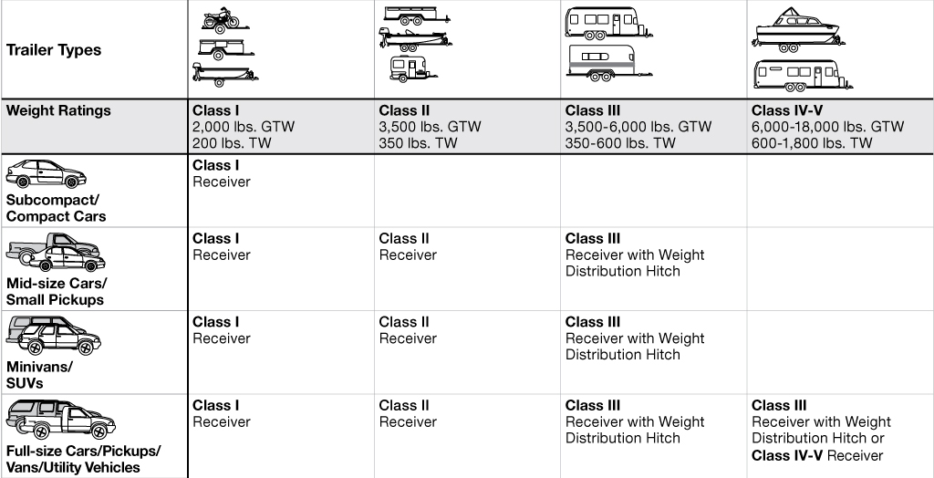

Vehicle Classifications
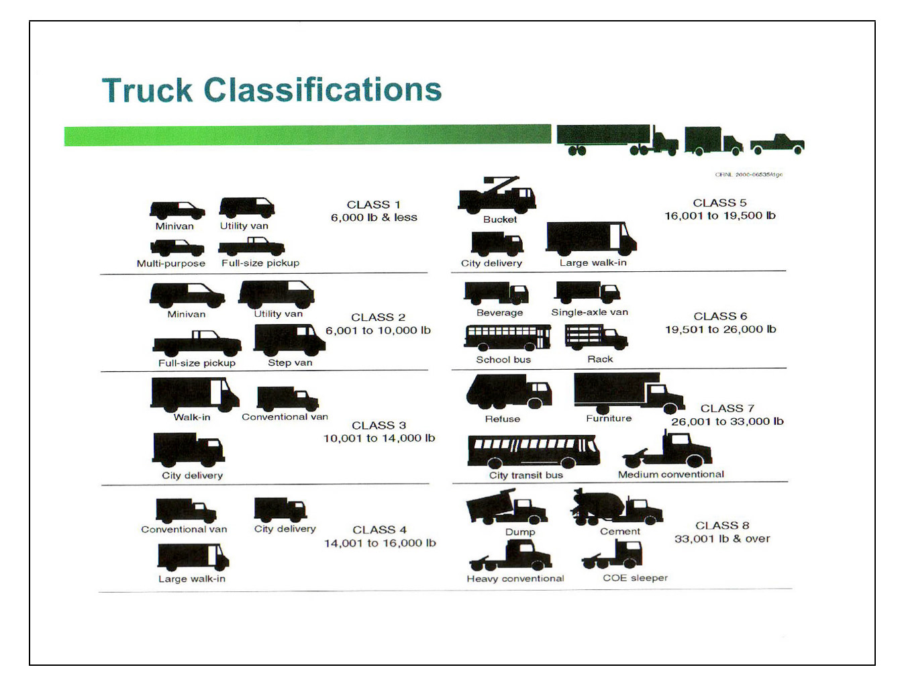

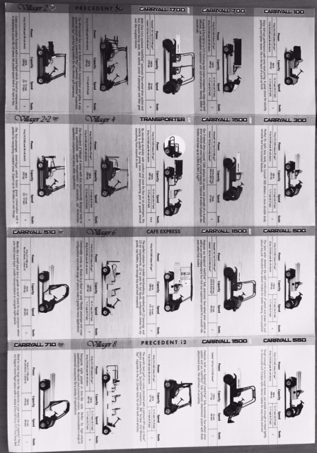
Section 3- Proposed New Vehicle Information
Vehicle # __________________________ Type: ______________________________________

Make ________________ Model ___________________Serial # ______________________________

Fuel Type: ____________________ Passenger Capacity: _____________________

Does this vehicle meet with the U.S. Department of Energy’s Alternative Fuel Transportation Program requirement? |  | Yes / No
Department________________________ Activity: _________________________________________

Campus Assignment: ___________________________ Parking Location: _______________________

Fleet Liaison: _________________________________ E-Mail: ________________________________

Phone # __________________________________________

Vendor Information: Contact:

Contract Information:

AIM Fuel Management System Requirement: | Yes |  | No
Sun Pass Transponder Requirement: | Yes |  | No

Approval
___________________________________________________ ______________________
Requester Date

___________________________________________________ ______________________
Fleet Manager Date

___________________________________________________ ______________________
User Department Approver Date

